Programming in databases

PL/SQL
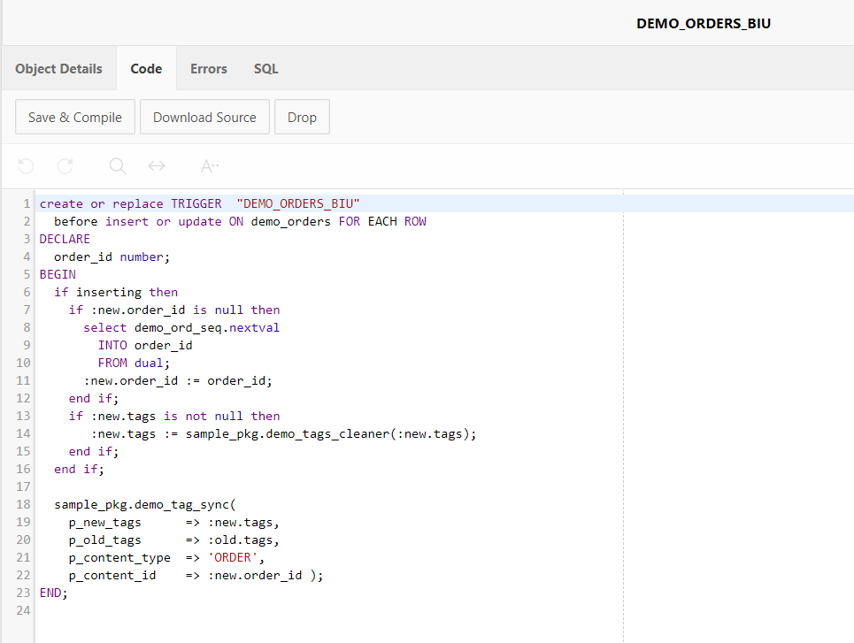

Note: These icons are used throughout this workbook:

 An example showing how to do something

 A task for you to complete

 Good to know!

An example and a task for you to complete

Check out these websites:

http://apex.oracle.com/pls/otn/f?p=33231:41:389827641840101::NO:41::

http://docs.oracle.com/cd/E37097_01/doc/index.htm

Table of Contents
Contents
Check out these websites: 2
1. PL/SQL and Triggers 4
Exercise 1: Triggers (open lecture slides on Triggers) 4
Exercise 2: Create an Exclusive Arc Trigger 5
Exercise 3: Trigger to enforce the referential integrity constraint (Foreign Key) 7
Exercise 4: Check Constraints Triggers 9
Appendix: Reading PL/SQL 12
An Introduction to Triggers 12
How Triggers Are Used 12
Triggers vs. Declarative Integrity Constraints 13
Parts of a Trigger 13
Triggering Event or Statement 14
Trigger Restriction 14
Trigger Action 15
Types of Triggers 15
Combinations 16
Trigger Execution 18
Data Access for Triggers 20
Storage for Triggers 22
Execution of Triggers 22
Dependency Maintenance for Triggers 22
Enforcing Referential Integrity Using Triggers 23
Transparent Event Logging and Triggers 27

1. PL/SQL and Triggers

IMPORTANT NOTE: Create an SQL script in SQL Scripts environment to write and run all of your PL/SQL code – always!

ORACLE allows you to define procedures that are automatically executed when an INSERT, UPDATE, or DELETE statement is issued against the associated table. These procedures are called database triggers.

Triggers are similar to stored procedures, while a procedure is explicitly executed by a user or an application, a trigger is implicitly fired (executed) by ORACLE when a triggering INSERT, UPDATE, or DELETE statement is issued, no matter what user is connected or what application is being used.

Triggers can only be defined on tables, not views. However, triggers on the base table(s) of a view are fired if an INSERT, UPDATE, or DELETE statement is issued against a view.

For further information on this topic, please go to Triggers Error: Reference source not found(ctrl + click to follow the link).

Write your code in SQL Commands enviroments, and results can be viewed and tested in Object Browser.


Exercise 1: Triggers (open lecture slides on Triggers)

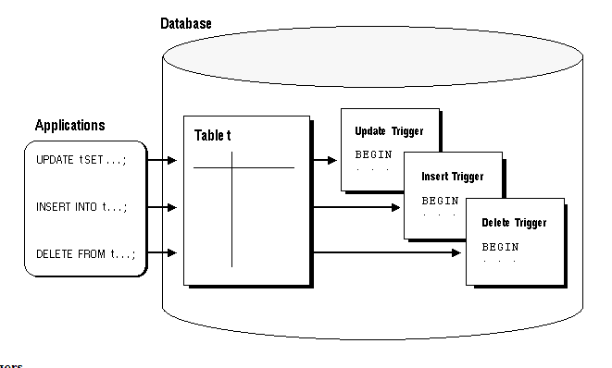

The following trigger is defined on the DEPT table to enforce the UPDATE and DELETE SET NULL referential action on the primary key of the DEPT table.

NOTE: Your tables emp and dept, must have PKs defined, and emp has to have a FK defined as well. Run your Scott script again, to make sure these are implemented.

- Type in and Run the following code in SQL Command:
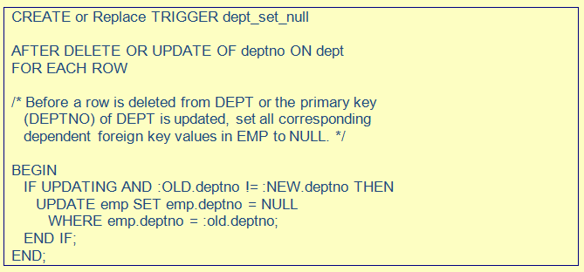
- To test the code, write an SQL UPDATE command to update dept number 10 to 80 in the dept table.

Updating row(s) syntax:

UPDATE dept SET deptno = 80 Where deptno = 10

Check APPENDIX D for other SQL and PL/SQL syntax guide.

- Then select all employees from the emp table. What has happened to those who worked in dept no 10? Does this trigger do the “job”?

Exercise 2: Create an Exclusive Arc Trigger

This trigger is used to ensure that an order is processed for either a company customer (cocustno) or an individual customer (indcustno). This is an exclusive arc relationship. We need a trigger to make sure a user does not insert the value of an order for both types of customers. Could be easily done when both columns are in the Order table. Make sure you save your code, call it Exclusive Arc trigger.

In a table it should look like:

Tmporder table
Id(PK) | Cocustno (FK) | Indcustno(FK)
1 | 1111 | null
2 | Null | 2222
3 | 1111 | null
4 | Null | 2222

- Log into Apex, go to SQL Commands.

- Type in and Run the following code to create a temp Order table:

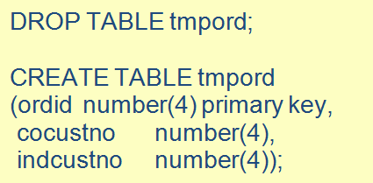

Note that cocustno and indcustno would be FK columns if all tables were implemented.

- Type in and Run the following code in SQL Command:

Note that the trigger does also provide the user with a user defined message, , that makes more sense than the default general message used by oracle.

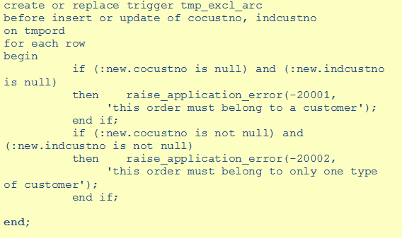

- Now test this code. First insert two rows of data, given below. Then write a statement to select all data from the tmpord table

insert into tmpord values (1, 1111, 2222);
insert into tmpord values (2, null, null);

insert into tmpord values (1, 1111, null);
insert into tmpord values (2, null, 2222);

SELECT * FROM tmpord

Exercise 3: Trigger to enforce the referential integrity constraint (Foreign Key)

You can create a trigger to make sure that a value a user enters in a column corresponds an existing value in another table’s column. Make sure you are saving your code, call it FK trigger.

- First we will drop (in case you already have this table), than create a temp_emp table, using SQL statements in SQL command.

DROP TABLE tmpemp

CREATE TABLE tmpemp AS SELECT * FROM scott.emp

- To check the data in the new table tmpemp, write an SQL statement

SELECT * FROM tmpemp

You will get
- Now, insert a new value in tmpemp table:
INSERT INTO tmpemp(empno, deptno) values (1111, 10);
INSERT INTO tmpemp(empno, deptno) values (2222, 50);
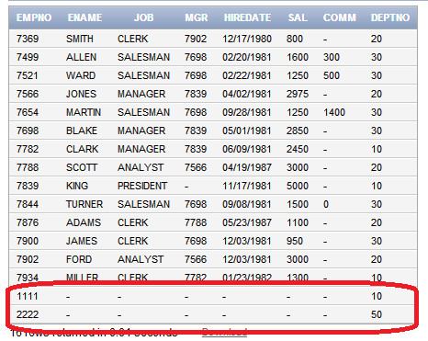

- Type in the trigger code in SQL Command and run it.

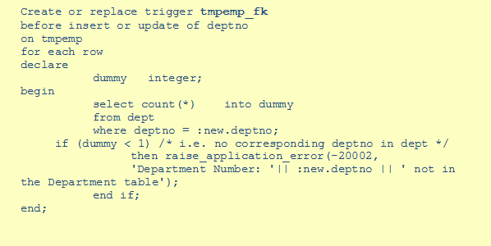

- The Trigger (tmpemp_fk) has been created even though we have values in tmpemp table that do not exist in the dept table, deptno 50. Note that the current table tmpemp hasn’t got a FK constraint implemented on it. You could check this in the Object Browser under the constraints tab on the table.
- However, from now on, this trigger will prevent you from being able to insert incorrect values in tmpemp table. Run this following code:

INSERT INTO tmpemp(empno, deptno) values (3333, 50);

- The trigger is working. It has “fired” and prevented you from entering wrong data in the tmpemp table. The following message will inform you that deptno 50 does not exist in the dept table
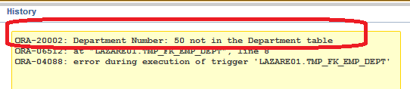

- Lesson learned here is that you have to create your trigger(s) before you insert any data in the table. You could repeat this task, so that deptno 50 is never allowed in the tmp table. How would you do this?

Exercise 4: Check Constraints Triggers

Check Constraint Triggers can enforce integrity rules other than referential integrity. For example, this trigger performs a complex check before allowing the triggering statement to execute. Comments within the code explain the functionality of the trigger.

You are in charge here. How would you run and test this code? What does the code do? Include your own comments in the code. Could you use this code in your Assignment?

DDL and DML code:

drop table tmpsalguide cascade constraints;
drop table tmpemp cascade constraints;
create table tmpemp as select * from scott.emp;
create table tmpsalguide
( job varchar2(9) primary key,
minsal number(7,2) not null,
maxsal number(7,2) );
insert into tmpsalguide values ('CLERK', 5000, 15000);
insert into tmpsalguide values ('ANALYST', 10000, 20000);
insert into tmpsalguide values ('MANAGER', 20000, 40000);
insert into tmpsalguide values ('SALESMAN', 5000, 30000);
insert into tmpsalguide values ('PRESIDENT', 50000,'' );
Trigger Code:
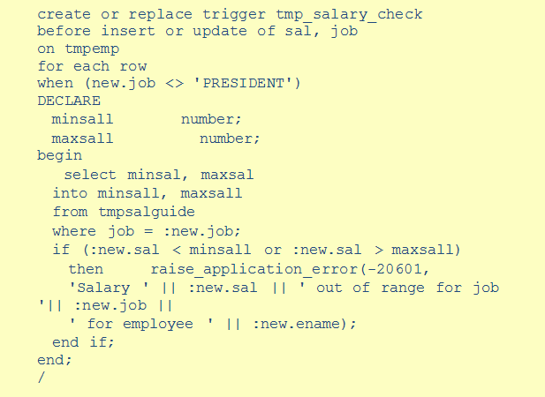
Test Code:
​
Now try to insert or update a salary for job CLERK to have a value of 4000.

Exercise: Complex Security Authorisations

Triggers are commonly used to enforce complex security authorisations for table data. Only use triggers to enforce complex security authorisations that cannot be defined using the database security features provided with ORACLE. For example, a trigger can prohibit updates to salary data of the EMP table during weekends, holidays, and non-working hours.

When using a trigger to enforce a complex security authorisation, it is best to use a BEFORE statement trigger. Using a BEFORE statement trigger has these benefits:
- The security check is done before the triggering statement is allowed to execute so that no wasted work is done by an unauthorised statement.
- The security check is performed only once for the triggering statement, not for each row affected by the triggering statement.

Type in the following code, run it and test the trigger. Create an INSERT OR DELETE OR UPDATE statement to test your trigger code.
- Create table company holidays with a column date. E.g. CREATE TABLE COMPANY_HOLIDAYS (DAY DATE);
- Insert one row of data with date that is today’s date. E.G INSERT INTO COMPANY_HOLIDAYS VALUES ('12/11/21');

- Create the trigger code below:
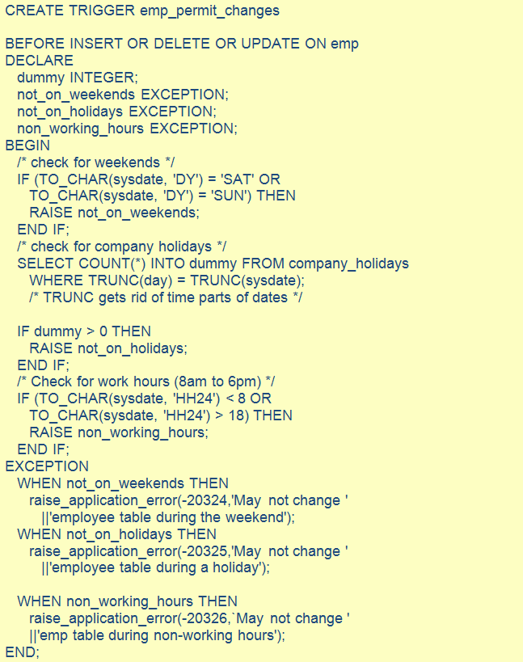

Appendix: Reading PL/SQL

“Don't fire until you see the whites of their eyes. “

William Prescott

This section discusses database triggers; that is, procedures that are stored in the database and implicitly executed ("fired") when a table is modified. Topics include:

- how triggers are used
- database triggers vs. SQL*Forms triggers
- triggers vs. declarative integrity constraints
- parts of a trigger
- how triggers are executed

Note: more about triggers can be found on the Oracle website
https://docs.oracle.com/cd/B19306_01/server.102/b14200/statements_7004.htm

An Introduction to Triggers
ORACLE allows you to define procedures that are implicitly executed when an INSERT, UPDATE, or DELETE statement is issued against the associated table. These procedures are called database triggers.

Triggers are similar to stored procedures, while a procedure is explicitly executed by a user or an application, a trigger is implicitly fired (executed) by ORACLE when a triggering INSERT, UPDATE, or DELETE statement is issued, no matter what user is connected or what application is being used.

Triggers can only be defined on tables, not views. However, triggers on the base table(s) of a view are fired if an INSERT, UPDATE, or DELETE statement is issued against a view.

How Triggers Are Used

In many cases, triggers supplement the standard capabilities of ORACLE to provide a highly customized database management system. For example, a trigger can permit DML operations (INSERT, DELETE and UPDATE statements) against a table only if they are issued during regular business hours. The standard security features of ORACLE, roles and privileges, govern which users can submit DML statements against the table. In addition, the trigger further restricts DML operations to occur only at certain times during weekdays. This is just one way that you can use triggers to customize information management in an ORACLE database.

In addition, triggers are commonly used to:
· automatically generate derived column values
· prevent invalid transactions
· enforce complex security authorizations
· enforce referential integrity across nodes in a distributed database
· enforce complex business rules
· provide transparent event logging
· provide sophisticated auditing
· maintain synchronous table replicates
· gather statistics on table access

A Cautionary Note About Trigger Use

When a trigger is fired, a SQL statement within its trigger action potentially can fire other triggers. When a statement in a trigger body causes another trigger to be fired, the triggers are said to be cascading.

While triggers are useful for customizing a database, you should only use triggers when necessary. The excessive use of triggers can result in complex interdependencies, which may be difficult to maintain in a large application.

Triggers vs. Declarative Integrity Constraints

Triggers and declarative integrity constraints can both be used to constrain data input. However, triggers and integrity constraints have significant differences.

A declarative integrity constraint is a statement about the database that is always true. A constraint applies to existing data in the table and any statement that manipulates the table.

Triggers constrain what transactions can do. A trigger does not apply to data loaded before the definition of the trigger; therefore, it does not guarantee all data in a table conforms to the rules established by an associated trigger.

A trigger enforces transitional constraints; that is, a trigger only enforces a constraint at the time that the data changes. Therefore, a constraint such as "make sure that the delivery date is at least seven days from today" should be enforced by a trigger, not a declarative integrity constraint.

In evaluating triggers that contain SQL functions that have NLS parameters as arguments, (for example, TO_CHAR, TO_DATE and TO_NUMBER), the default values for these parameters are taken from the NLS parameters currently in effect for the session. You can override the default values by specifying NLS parameters explicitly in such functions when you create a trigger.

Parts of a Trigger

A trigger has three basic parts:

· a triggering event or statement
· a trigger restriction
· a trigger action

Each part of a trigger is explained in greater detail in the following sections.

Triggering Event or Statement

A triggering event or statement is the SQL statement that causes a trigger to be fired. A triggering event can be an INSERT, UPDATE, or DELETE statement for a specific table.

For example, the triggering statement is:

. . . UPDATE OF parts_on_hand ON inventory . . .

Which means that when the PARTS_ON_HAND column of a row in the INVENTORY table is updated, fire the trigger. Note that when the triggering event is an UPDATE statement, you can include a column list to identify which columns must be updated to fire the trigger; because INSERT and DELETE statements affect entire rows of information, a column list cannot be specified for these options.

A triggering event can specify multiple DML statements, as in:

. . . INSERT OR UPDATE OR DELETE OF inventory . . .

Which means that when an INSERT, UPDATE, or DELETE statement is issued against the INVENTORY table, fire the trigger. When multiple types of DML statements can fire a trigger, conditional predicates can be used to detect the type of triggering statement; therefore, a single trigger can be created that executes different code based on the type of statement that fired the trigger.

Trigger Restriction

A trigger restriction specifies a Boolean (logical) expression that must be TRUE for the trigger to fire. The trigger action is not executed if the trigger restriction evaluates to FALSE.

A trigger restriction is an option available for triggers that are fired for each row. Its function is to conditionally control the execution of a trigger. A trigger restriction is specified using a WHEN clause. The trigger is fired by an UPDATE statement affecting the PARTS_ON_HAND column of the INVENTORY table, but the trigger action only fires if the following expression is TRUE:

new.parts_on_hand < new.reorder_point

Trigger Action

A trigger action is the procedure (PL/SQL block) that contains the SQL statements and PL/SQL code to be executed when a triggering statement is issued and the trigger restriction evaluates to TRUE.

Similar to stored procedures, a trigger action can contain SQL and PL/SQL statements; can define PL/SQL language constructs (variables, constants, cursors, exceptions, etc.); and can call stored procedures. Additionally, for row triggers, the statements in a trigger action have access to column values (new and old) of the current row being processed by the trigger. Two correlation names provide access to the old and new values for each column.

Types of Triggers

When you define a trigger, you can specify the number of times the trigger action is to be executed: once for every row affected by the triggering statement (such as might be fired by an UPDATE statement that updates many rows), or once for the triggering statement, no matter how many rows it affects.

Row Triggers
A row trigger is fired each time the table is affected by the triggering statement. For example, if an UPDATE statement updates multiple rows of a table, a row trigger is fired once for each row affected by the UPDATE statement. If a triggering statement affects no rows, a row trigger is not executed at all.

Row triggers are useful if the code in the trigger action depends on data provided by the triggering statement or rows that are affected.

Statement Triggers
A statement trigger is fired once on behalf of the triggering statement, regardless of the number of rows in the table that the triggering statement affects (even if no rows are affected). For example, if a DELETE statement deletes several rows from a table, a statement-level DELETE trigger is fired only once, regardless of how many rows are deleted from the table.

Statement triggers are useful if the code in the trigger action does not depend on the data provided by the triggering statement or the rows affected. For example, if a trigger makes a complex security check on the current time or user, or if a trigger generates a single audit record based on the type of triggering statement, a statement trigger is used.

BEFORE vs. AFTER Triggers
When defining a trigger, you can specify the trigger timing; that is, you can specify when the trigger action is to be executed in relation to the triggering statement: before or after the triggering statement. BEFORE and AFTER apply to both statement and row triggers.

BEFORE Triggers BEFORE triggers execute the trigger action before the triggering statement. This type of trigger is commonly used in the following situations:

· BEFORE triggers are used when the trigger action should determine whether or not the triggering statement should be allowed to complete. By using a BEFORE trigger for this purpose, you can eliminate unnecessary processing of the triggering statement and its eventual rollback in cases where an exception is raised in the trigger action.

· BEFORE triggers are used to derive specific column values before completing a triggering INSERT or UPDATE statement.

AFTER Triggers AFTER triggers execute the trigger action after the triggering
statement is executed. AFTER triggers are used in the following situations:

· AFTER triggers are used when you want the triggering statement to complete before executing the trigger action.

· If a BEFORE trigger is already present, an AFTER trigger can perform different actions on the same triggering statement.

Combinations

Using the options listed in the previous two sections, you can create four types of triggers:

· BEFORE statement trigger
Before executing the triggering statement, the trigger action is executed.

· BEFORE row trigger
Before modifying each row affected by the triggering statement and before checking appropriate integrity constraints, the trigger action is executed if the trigger restriction either evaluated to TRUE or was not included.

· AFTER statement trigger
After executing the triggering statement and applying any deferred integrity constraints, the trigger action is executed.

· AFTER row trigger
After modifying each row affected by the triggering statement and possibly applying appropriate integrity constraints, the trigger action is executed for the current row if the trigger restriction either evaluated to TRUE or was not included. Unlike BEFORE row triggers, AFTER row triggers have rows locked.

For example, suppose you have a table, SAL, and you want to know when the table is being accessed, and the types of queries being issued. The following package and trigger tracks this information by hour and type of action (for example UPDATE, DELETE or INSERT) on table SAL. A global session variable, STAT.ROWCNT, is initialized to zero by a BEFORE statement trigger, then it is incremented each time the row trigger is executed, and finally the statistical information is saved in the table STAT_TAB by the AFTERstatement trigger.


DROP TABLE stat_tab;

CREATE TABLE stat_tab(utype CHAR(8),

rowcnt INTEGER, uhour INTEGER);

CREATE OR REPLACE PACKAGE stat IS

rowcnt INTEGER;

END;
/

CREATE TRIGGER bt BEFORE UPDATE OR DELETE OR INSERT ON sal

BEGIN
stat.rowcnt := 0;

END;

/

CREATE TRIGGER rt BEFORE UPDATE OR DELETE OR INSERT ON sal
FOR EACH ROW BEGIN
stat.rowcnt := stat.rowcnt + 1;
END;

/

CREATE TRIGGER at AFTER UPDATE OR DELETE OR INSERT ON sal
DECLARE
typ CHAR(8);
hour NUMBER;
BEGIN
IF updating
THEN typ := 'update'; END IF;
IF deleting THEN typ := 'delete'; END IF;
IF inserting THEN typ := 'insert'; END IF;
hour := TRUNC((SYSDATE - TRUNC(SYSDATE)) * 24);
UPDATE stat_tab
SET rowcnt = rowcnt + stat.rowcnt
WHERE utype = typ
AND uhour = hour;

IF SQL%ROWCOUNT = 0 THEN
INSERT INTO stat_tab VALUES (typ, stat.rowcnt, hour);
END IF;
EXCEPTION
WHEN dup_val_on_index THEN
UPDATE stat_tab
SET rowcnt = rowcnt + stat.rowcnt
WHERE utype = typ
AND uhour = hour;
END;
/ _______________________________________

Trigger Execution

A trigger can be in either of two distinct modes:

Enabled: An enabled trigger executes its trigger action if a triggering
statement is issued and the trigger restriction (if any) evaluates to TRUE.

Disabled: A disabled trigger does not execute its trigger action, even if a triggering statement is issued and the trigger restriction (if any) would evaluate to TRUE.

For enabled triggers, ORACLE automatically:

· executes triggers in a planned firing sequence when more than one trigger is fired by a single SQL statement
· performs integrity constraint checking at a set point in time with respect to the different
types of triggers and guarantees that triggers cannot compromise integrity constraints
· provides read-consistent views for queries and constraints
· manages the dependencies among triggers and objects referenced in the code of the trigger action
· uses two-phase commit if a trigger updates remote tables

The Execution Model for Triggers and Integrity Constraint Checking

A single SQL statement can potentially fire up to four triggers: a BEFORE row trigger, BEFORE statement trigger, AFTER row trigger, and AFTER statement trigger. A triggering statement or a statement within a trigger can cause one or more integrity constraints to be checked. Also, triggers can contain statements that cause other triggers to fire (cascading triggers). ORACLE uses the following execution model to maintain the proper firing sequence of multiple triggers and constraint checking.

1. Execute BEFORE statement trigger.
2. Loop for each row affected by the SQL statement.
a. Execute BEFORE row trigger.
b. Lock and change row, and perform integrity constraint
checking (The lock is not released until the
transaction is committed.)
c. Execute AFTER row trigger.
3. Complete deferred integrity constraint checking.
4. Execute AFTER statement trigger.

The definition of the execution model is recursive. For example, a given SQL statement can cause a BEFORE row trigger to be fired and an integrity constraint to be checked. That BEFORE row trigger, in turn, might perform an update that causes an integrity constraint to be checked and an AFTER statement trigger to be fired. The AFTER statement trigger causes an integrity constraint to be checked. In this case, the execution model executes the steps recursively, as follows:

Original SQL statement issued.
BEFORE row trigger fired.
AFTER statement trigger fired by UPDATE in
BEFORE row trigger.
Statements of AFTER statement trigger
executed.
Integrity constraint on tables changed by
AFTER statement trigger checked.
Statements of BEFORE row trigger executed.
Integrity constraint on tables changed by
BEFORE row trigger checked.
SQL statement executed.
Integrity constraint from an SQL statement checked.

An important property of the execution model is that all actions and checks done as a result of a SQL statement must succeed. If an exception is raised within a trigger and the exception is not explicitly handled, all actions performed as a result of the original SQL statement, including the actions performed by fired triggers, are rolled back. Thus, integrity constraints cannot be compromised by triggers. The execution model takes into account integrity constraints and disallows triggers that could violate declarative integrity constraints.

For example, in the previously outlined scenario, suppose that Steps 1 through 8 succeed; however, in Step 9 the integrity constraint is violated. As a result of this violation, all changes made by the SQL statement (in Step 8), the fired BEFORE row trigger (in Step 6), and the fired AFTER statement trigger (in Step 4) are rolled back.

Data Access for Triggers

When a trigger is fired, the tables referenced in the trigger action might be currently undergoing changes by SQL statements contained in other users' transactions. In all cases, the SQL statements executed within triggers follow the common rules used for stand-alone SQL statements. In particular, if an uncommitted transaction has modified values that a trigger being fired either needs to read (query) or write (update), the SQL statements in the body of the trigger being fired use the following guidelines:

· Queries see the current read-consistent snapshot of referenced tables and any data changed within the same transaction.

· Updates wait for existing data locks before proceeding.


The following examples illustrate these points.

Assume that the SALARY_CHECK trigger (body) includes the following
SELECT statement:

SELECT minsal, maxsal INTO minsal, maxsal
FROM salgrade
WHERE job_classification = :new.job_classification;

For this example, assume that transaction T1 includes an update to the MAXSAL column of the SALGRADE table. At this point, the SALARY_CHECK trigger is fired by a statement in transaction T2. The SELECT statement within the fired trigger (originating from T2) does not see the update by the uncommitted transaction T1, and the query in the trigger returns the old MAXSAL value as of the read-consistent point for transaction T2.

Type in the following code, run it and test the trigger.

Assume the following definition of the TOTAL_SALARY trigger, a trigger to maintain a derived column that stores the total salary of all members in a department:

-- First, create a dept5 and emp5 tables and populate few records. Dept5 table will have a new column total_sal.
CREATE TABLE DEPT5 (
DEPTNO NUMBER (2) ,
DNAME VARCHAR2 (14),
LOC VARCHAR2 (13),
total_sal number(8),
CONSTRAINT PK_DEPT5 PRIMARY KEY ( DEPTNO ));

CREATE TABLE EMP5 (
EMPNO NUMBER (4) ,
ENAME VARCHAR2 (10),
JOB VARCHAR2 (9),
MGR NUMBER (4),
HIREDATE DATE,
SAL NUMBER (7,2) Not Null,
COMM NUMBER (7,2),
DEPTNO NUMBER (2) REFERENCES dept5 (DEPTNO),
CONSTRAINT PK_EMP PRIMARY KEY ( EMPNO ));

INSERT INTO DEPT5 VALUES (10, 'ACCOUNTING', 'NEW YORK', 10);
INSERT INTO EMP5 values(7369, 'SMITH', 'CLERK ', 7902, '12/17/80', 800, null, 10);

--Then create a trigger total_sal

CREATE or REPLACE TRIGGER total_salary
AFTER DELETE OR INSERT OR UPDATE OF deptno, sal ON emp5
FOR EACH ROW BEGIN
/* assume that DEPTNO and SAL are non-null fields */
IF DELETING OR (UDATING AND :old.deptno != :new.deptno)
THEN UPDATE dept5
SET total_sal = total_sal - :old.sal
WHERE deptno = :old.deptno;
END IF;
IF INSERTING OR (UPDATING AND :old.deptno != :new.deptno)
THEN UPDATE dept5
SET total_sal = total_sal + :new.sal
WHERE deptno = :new.deptno;
END IF;
IF (UPDATING AND :old.deptno = :new.deptno AND
:old.sal != :new.sal )
THEN UPDATE dept 5
SET total_sal = total_sal - :old.sal + :new.sal
WHERE deptno = :new.deptno;
END IF;
END;
));

For this example, suppose that one user's uncommitted transaction includes an update to the TOTAL_SAL column of a row in the DEPT table. At this point, the TOTAL_SALARY trigger is fired by a second user's SQL statement. Because the uncommitted transaction of the first user contains an update to a pertinent value in the TOTAL_SAL column (i.e., a row lock is being held), the updates performed by the TOTAL_SALARY trigger are not executed until the transaction holding the row lock is committed or rolled back. Therefore, the second user waits until the commit or rollback point of the first user's transaction.

Storage for Triggers

Unlike stored procedures, only the source code of a database trigger is stored in the database. Upon first execution, the source code of a trigger is compiled and cached in the shared pool. If the trigger is flushed from the shared pool, the source code of the trigger must be recompiled when used.

Execution of Triggers

ORACLE internally executes a trigger using the same steps used for procedure execution, as explained in "How ORACLE Executes Procedures and Packages" on page 14 - 17. The only subtle difference is that user access to fire a trigger is verified if a user has the privilege to execute a triggering statement. Other than this, triggers are validated and executed the same way as stored procedures.

Dependency Maintenance for Triggers

ORACLE automatically manages the dependencies of a trigger on the schema objects referenced in its trigger action. However, such dependencies are only managed once a trigger is in the shared pool, and dependencies are not managed in quite the same way that dependencies are managed for stored procedures.
Integrity Constraints and Triggers

Triggers and declarative integrity constraints can both be used to constrain data input. However, triggers and integrity constraints have significant differences.

Declarative integrity constraints are statements about the database that are always true. A constraint applies to existing data in the table and any statement that manipulates the table; for more information, see Chapter 6.

Triggers constrain what a transaction can do. A trigger does not apply to data loaded before the definition of the trigger; therefore, it is not known if all data in a table conforms to the rules established by an associated trigger.

Enforcing Referential Integrity Using Triggers

Many cases of referential integrity can be enforced using triggers. However, only use triggers when you want to enforce the UPDATE and DELETE SET NULL, and UPDATE and DELETE SET DEFAULT referential actions or when you want to enforce referential integrity between parent and child tables on different nodes of a distributed database.

When using triggers to maintain referential integrity, declare the PRIMARY (or UNIQUE) KEY constraint on the parent table. If referential integrity is being maintained between a parent and child table in the same database, you can also declare the foreign key in the child table, but disable it; this prevents the corresponding PRIMARY KEY constraint from being dropped (unless the PRIMARY KEY constraint is explicitly dropped with the CASCADE option).

To maintain referential integrity using triggers:
· A trigger must be defined for the child table that guarantees values inserted or updated in the foreign key correspond to values in the parent key.

· One or more triggers must be defined for the parent table. These triggers guarantee the desired referential action (RESTRICT, CASCADE, or SET NULL) for values in the foreign key when values are updated or deleted in the parent key. No action is required for inserts into the parent table (no dependent foreign keys exist).

The following sections provide examples of the triggers necessary to enforce referential integrity. The EMP and DEPT table relationship is used in these examples.

Several of the triggers include statements that lock rows (SELECT ... FOR UPDATE). This operation is necessary to maintain concurrency as the rows are being processed.

Foreign Key Trigger for Child Table The following trigger guarantees that before an INSERT or UPDATE statement affects a foreign key value, the corresponding value exists in the parent key. The mutating table exception included in the example below allows this trigger to be used in conjunction with the UPDATE_SET_DEFAULT and UPDATE_CASCADE triggers. This exception can be removed if this trigger is used alone.
Type in the following code, run it and test the trigger.

CREATE TRIGGER emp_dept_check

BEFORE INSERT OR UPDATE OF deptno ON emp
FOR EACH ROW WHEN (new.deptno IS NOT NULL)

/* Before a row is inserted, or DEPTNO is updated in the EMP
table, fire this trigger to verify that the new foreign
key value (DEPTNO) is present in the DEPT table. */

DECLARE
dummy INTEGER; /* used for cursor fetch below */
invalid_department EXCEPTION;
valid_department EXCEPTION;
mutating_table EXCEPTION;
PRAGMA EXCEPTION_INIT (mutating_table, -4091);

/* Cursor used to verify the parent key value exists. If
present, lock parent key's row so it can't be
deleted by another transaction until this
transaction is committed or rolled back. */

CURSOR dummy_cursor (dn NUMBER) IS
SELECT deptno
FROM dept
WHERE deptno = dn
FOR UPDATE OF deptno;

BEGIN
OPEN dummy_cursor (:new.deptno);
FETCH dummy_cursor INTO dummy;

/* Verify parent key. If not found, raise user-specified
error number and message. If found, close cursor

before allowing triggering statement to complete. */

IF dummy_cursor%NOTFOUND THEN
RAISE invalid_department;
ELSE
RAISE valid_department;
END IF;
EXCEPTION
WHEN invalid_department THEN
raise_application_error(-20000, 'Invalid Department'
|| ' Number' || TO_CHAR(:new.deptno)):
CLOSE dummy_cursor;
WHEN valid_department THEN
CLOSE dummy_cursor;
WHEN mutating_table THEN
NULL;
END;

UPDATE and DELETE RESTRICT Trigger for the Parent Table The following trigger is defined on the DEPT table to enforce the UPDATE and DELETE RESTRICT referential action on the primary key of the DEPT table:

Type in the following code, run it and test the trigger.

CREATE TRIGGER dept_restrict

AFTER DELETE OR UPDATE OF deptno ON dept
FOR EACH ROW

/* Before a row is deleted from DEPT or the primary key
(DEPTNO) of DEPT is updated, check for dependent
foreign key values in EMP; rollback if any arefound. */
DECLARE
dummy INTEGER; /* used for cursor fetch below */
employees_present EXCEPTION;
employees_not_present EXCEPTION;

/* Cursor used check for dependent foreign key values. */

CURSOR dummy_cursor (dn NUMBER) IS
SELECT deptnoFROM emp WHERE deptno = dn;

BEGIN
OPEN dummy_cursor (:old.deptno);
FETCH dummy_cursor INTO dummy;

/* If dependent foreign key is found, raise user-specified
error number and message. If notfound, close cursor
before allowing triggeringstatement to complete. */

IF dummy_cursor%FOUND THEN
RAISE employees_present; /* dependent rows exist */
ELSE
RAISE employees_not_present; /* no dependent rows */
END IF;
EXCEPTION
WHEN employees_present THEN
raise_application_error(-20001, 'Employees Present in'

|| ' Department ' || TO_CHAR(:old.deptno));
CLOSE dummy_cursor;
WHEN employees_not_present THEN
CLOSE dummy_cursor;
END;

Note: This trigger will not work with self-referential tables (that is, tables with both the primary/unique key and the foreign key).

Also, this trigger does not allow triggers to cycle (such as, A fires B fires A).

UPDATE and DELETE SET NULL Triggers for Parent Table
The following trigger is defined on the DEPT table to enforce the UPDATE and DELETE SET NULL referential action on the primary key of the DEPT table:

Type in the following code, run it and test the trigger.

CREATE TRIGGER dept_set_null

AFTER DELETE OR UPDATE OF deptno ON dept
FOR EACH ROW

/* Before a row is deleted from DEPT or the primary key
(DEPTNO) of DEPT is updated, set all corresponding
dependent foreign key values in EMP to NULL. */

BEGIN
IF UPDATING AND :OLD.deptno != :NEW.deptno THEN
UPDATE empSET emp.deptno = NULL
WHERE emp.deptno = :old.deptno;
END IF;
END;

DELETE Cascade Trigger for Parent Table
The following trigger on the DEPT table enforces the DELETECASCADE referential action on the primary key of the DEPT table:
Type in the following code, run it and test the trigger.

CREATE TRIGGER dept_del_cascade

AFTER DELETE ON dept
FOR EACH ROW

/* Before a row is deleted from DEPT, delete all
rows from the EMP table whose DEPTNO is the same as
the DEPTNO being deleted from the DEPT table. */

BEGIN
DELETE FROM emp
WHERE emp.deptno = :old.deptno;
END;

Note: Typically, the code for DELETE cascade is combined with the code for UPDATE SET NULL or UPDATE SET DEFAULT to account for both updates and deletes.

Transparent Event Logging and Triggers

Triggers are very useful when you want to transparently perform a related change in the database following certain events.

Example The REORDER trigger example shows a trigger that reorders parts as necessary when certain conditions are met (that is, a triggering statement is issued and the PARTS_ON_HAND value is less than the REORDER_POINT value).

Derived Column Values and Triggers

Triggers can derive column values automatically based upon a value provided by an INSERT or UPDATE statement. This type of trigger is useful to force values in specific columns that depend on the values of other columns in the same row. BEFORE row triggers are necessary to complete this type of operation because:

The dependant values must be derived before the insert or update occurs so that the triggering statement can use the derived values.

The trigger must fire for each row affected by the triggering INSERT or UPDATE statement.

The following example illustrates how a trigger can be used to derive new column values for a table whenever a row is inserted or updated. Comments within the code explain its functionality. Type in the following code, run it and test the trigger. Create an INSERT OR UPDATE statement to test your trigger code.

CREATE TRIGGER emp_derived

BEFORE INSERT OR UPDATE OF ename ON emp

/* Before updating the ENAME field, derive the values for
the UPPERNAME and SOUNDEXNAME fields. Users should be
restricted from updating these fields directly. */
FOR EACH ROW
BEGIN
:new.uppername := UPPER(:new.ename);
:new.soundexname := SOUNDEX(:new.ename);
END;

Document End ☺

